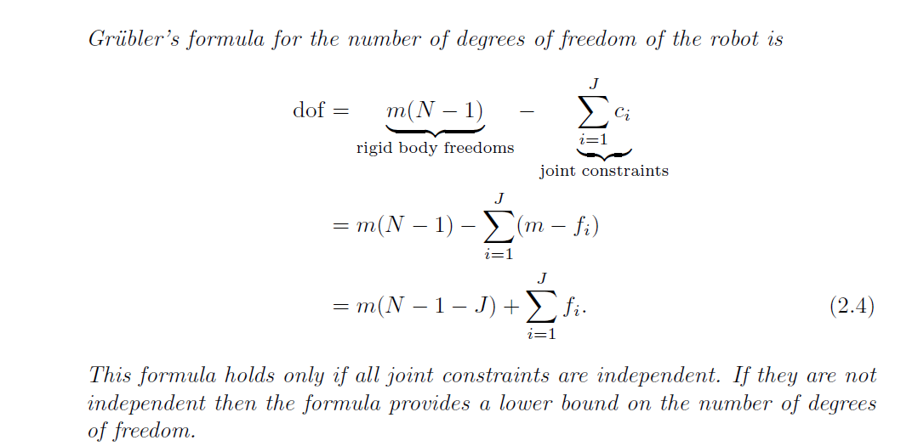

m= degree of freedom for a single body

3 for planner bodies

6 for spatial bodies

N= NUMBER OF LINKS (by historical convention N includes ground as link)

**J**= NUMBER OF JOINTS

**f** = freedom of joint